 **“ EMPOWERMENT THROUGH TECHNOLOGICAL EXCELLENCE ”**

# GENBA SOPANRAO MOZE COLLEGE OF ENGINEERING

B**alewadi, Pune- 411 045.**

**Department of Electronics and Telecommunications**

**Experiment**

**No.**

**–**

**Subject:**

**-**

**Mobile**

**Computing**

**Name of**

**the**

**Student:**

**Roll**

**No.**

**Date:**

**Marks**

**&**

**Signature:**

**Subject**

**Teacher**

**Aim:** To understand the handover mechanism.

**Objectives:**

To study the effect of handover threshold and margin on SINR and call drop probability and handover probability

**Prerequisite:**

**Operating System: Windows 7**

**Java Version: 6 only**

**Mozilla Firefox: version: 47.0.1 Link to download software:**

[**https://drive.google.com/uc?id=0B9mNeu43jUidckFYVTlnenpJRGs&export=download**](https://drive.google.com/uc?id=0B9mNeu43jUidckFYVTlnenpJRGs&export=download)

**Theory: Handoff**

Consider the figure below Initially say the mobile M is quite close to the base station A and hence receives signal strength from A PArx>PBrx . As the mobile moves away from the base station. A and goes towards B then the signal strength from A keeps falling (pathloss increases).Let there be a minimum sensibility level P0rx0 for the mobile, i.e. if the signal from the B.S.to which the mobile is connected falls below P0rx0 then the call drops. In order to prevent call drop the mobile monitors receive signal strength from the neighboring 3-6 B.S.. These neighboring 3-6 B.S. also monitor Rx signal strength from the M.S.

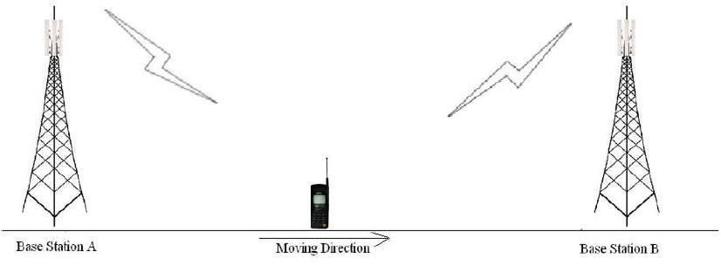

The mobile should get connected to B.S. which has the highest signal strength. However, if the M.S. continuously attaches itself to the B.S. with instantaneous height signal strength then the h/o rate may very high in server condition.

Thus, some hysten's condition is used for h. If PTrx (T= target B.S.) > Phrxℎ higher h/o threshold and ¯¯¯¯¯Pcrx¯ (c=current B.S.) < Phrxℎ minimum h/o threshold the execute h/o to BST from BSc.

Thus, it is threshold impeditive to study in part of the handoff process.

Δγ=Phrx−PlrxΔ=ℎ-

A successful handoff is one where the call gets from and continuous without call or in other words the h occurs before h/o Pcrx becomes <P0rx<0. If Pcrx<P0rx0 then call drop event occurs.

One would like to minimize the no of handoff events as well as minimize call drop probability. The experiment provides opportunity to study the inherent of these three parameters on h/o.

Further the averaging window for calculating PTrx and Pcrx also plays a role in the process. In the experiment small scale fading is not considered and hence the averaging considered only shadowing.

Students conducting the experiment is expected to study the impact of these on h/0. He/She is encouraged to respect the experiment for several sets of values of these parameters these draw conclusion.

**Instruction** Follow the instructions given below to perform the experiments.

1.1 Starting the Experiments: -

## • . Step1: Click on START button to start experiment. 



## • Step2: Enter your name then click OK button. 

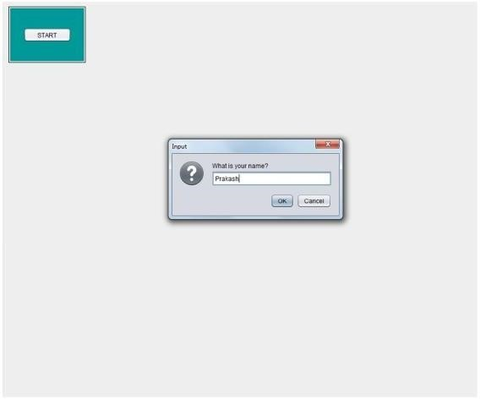

* Step3: Select the parameters (e.g.: Reuse, Environment, Beamwidth, Carrier frequency etc.) 

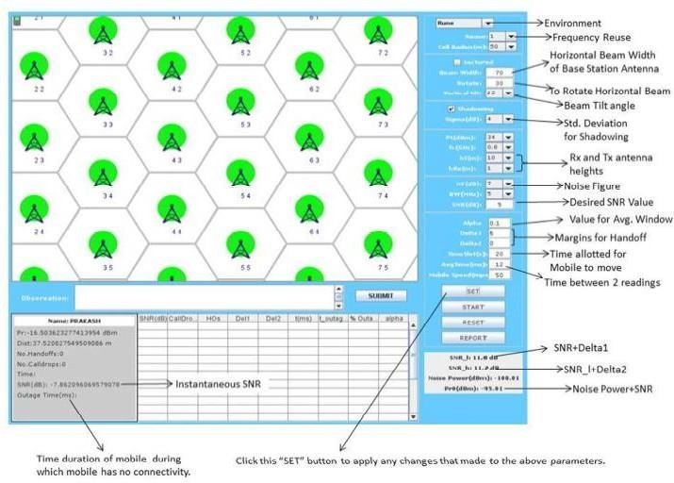

* Step4: Click on START button and observe No. of Call Drops and No. of Handoffs.

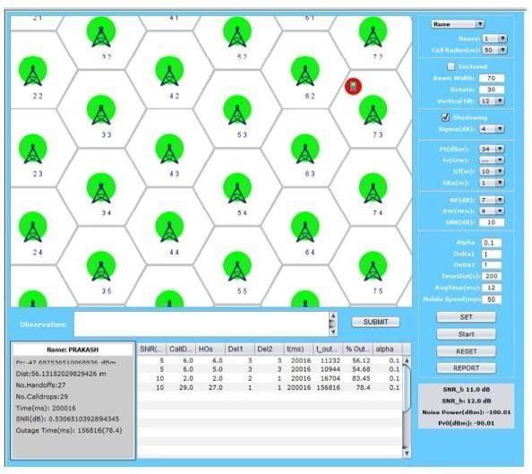

* Step5: Enter your observation in the OBSERVATION box and Click on SUBMIT button. 

## • Step6: Finally, click on REPORT to generate PDF report of the experiment. 

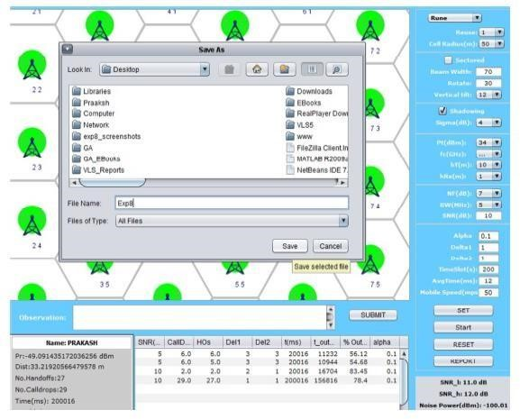

## • Step7: After PDF report generation you will get following message. 

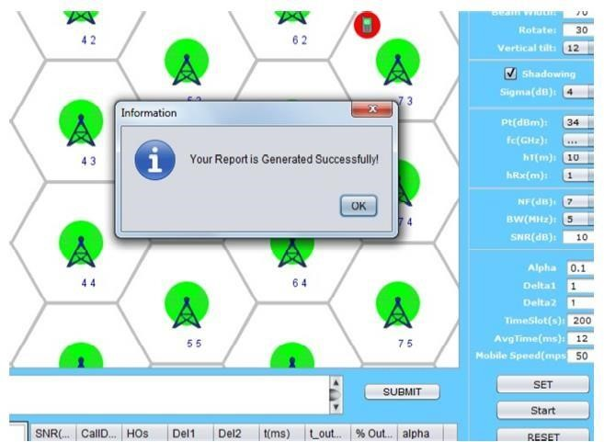

## • Step8: PDF report will appear like this. 

 

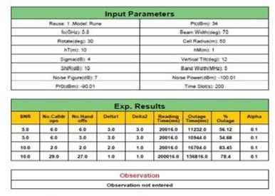

 Step9: To redo experiment click on RESET button.

Observation Table:

|  |  |  |  |  |
| --- | --- | --- | --- | --- |
| **Reuse** | **No of Hand Off** | **Mobile Speed** | **Outage** | **Outage**  **Percentage** |
| **1** |  |  |  |  |
| **3** |  |  |  |  |

Keep reuse ratio 3 and set mobile speed to 50 mps and 100 mps and record the below data. What do we observe after increasing the speed of the mobile station?

|  |  |  |  |  |
| --- | --- | --- | --- | --- |
| **Reuse** | **Mobile Speed** | **No of Hand off** | **Outage** | **Outage**  **Percentage** |
| **3** | **50** |  |  |  |
| **3** | **100** |  |  |  |

FAQ:

1. What is handoff?
2. What is the condition for handoff?
3. Explain Handoff and its types.

